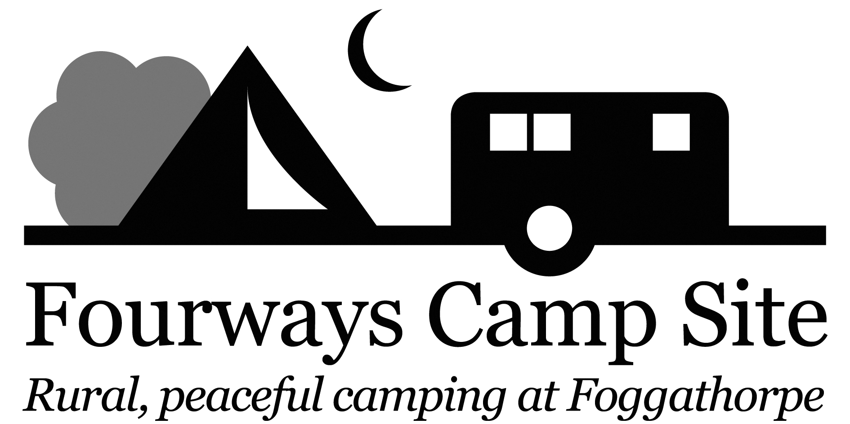

All prices are per night for 1 pitch, 1 vehicle, 2 adults and 2 children for caravan, campervan, motor home, tent or trailer tent.

Grass Pitch Rate £15.00 / Night
Grass Pitch Rate with EHU £18.00 /Night
Extra Adult per night £2
Extra Child per night £1
Awning/Gazebo per night £2
Small Porch per night £1
Large Tents subject to surcharge of £2 per night
Additional Car £3 per night
Dogs £1 per night
Shower free
Maximum occupancy per unit is 6 people.
Arrival after 12 noon
Departure before 11am
Email: fourwayscampsite@ymail.com
WWW.fourwayscampsite.com
TEL: 07432 491526 Martin or 07768 755585 Sue / 01757 289930 Fourways
Fourways Camp Site, Foggathorpe, Nr York, YO8 6PR
…………………………………………………………………………………………………………………………………… BOOKING IN FORM TO BE COMPLETED ON DAY OF ARRIVAL AND RETURNED WITH FULL PAYMENT
NAME ………………………………………………………………………………………………………………………………………………
ADDRESS………………………………………………………………………………………………………………………………………….
…………………………………………………………………………………………………………………………………………………………
…………………………………………………………………………………………………………………………………………………………
TEL NO …………………………………………………………………………………………………………………………………………….
EMAIL ………………………………………………………………………………………………………………………………………………
CAR REGISTRATION …………………………………………………………………………………………………………………………
MEMBER NO …………………………………………………………………………………………………………………………………..
TYPE OF UNIT…………………………………………………………………………………………………………………………………..
ARRIVAL DATE………………………………………………………………………………………………………………………………….
DEPARTURE DATE…………………………………………………………………………………………………………………………….
NUMBER OF NIGHTS………………………………………………………………............................................................
NUMBER OF ADULTS………………………………………………………………………………………………………………………..
NUMBER OF CHILDREN………………………………………………………………….....................................................
NUMBER OF DOGS…………………………………………………………………………………………………………………………….
DEPOSIT PAID …………………………………………………………………………………………………………………………………...

