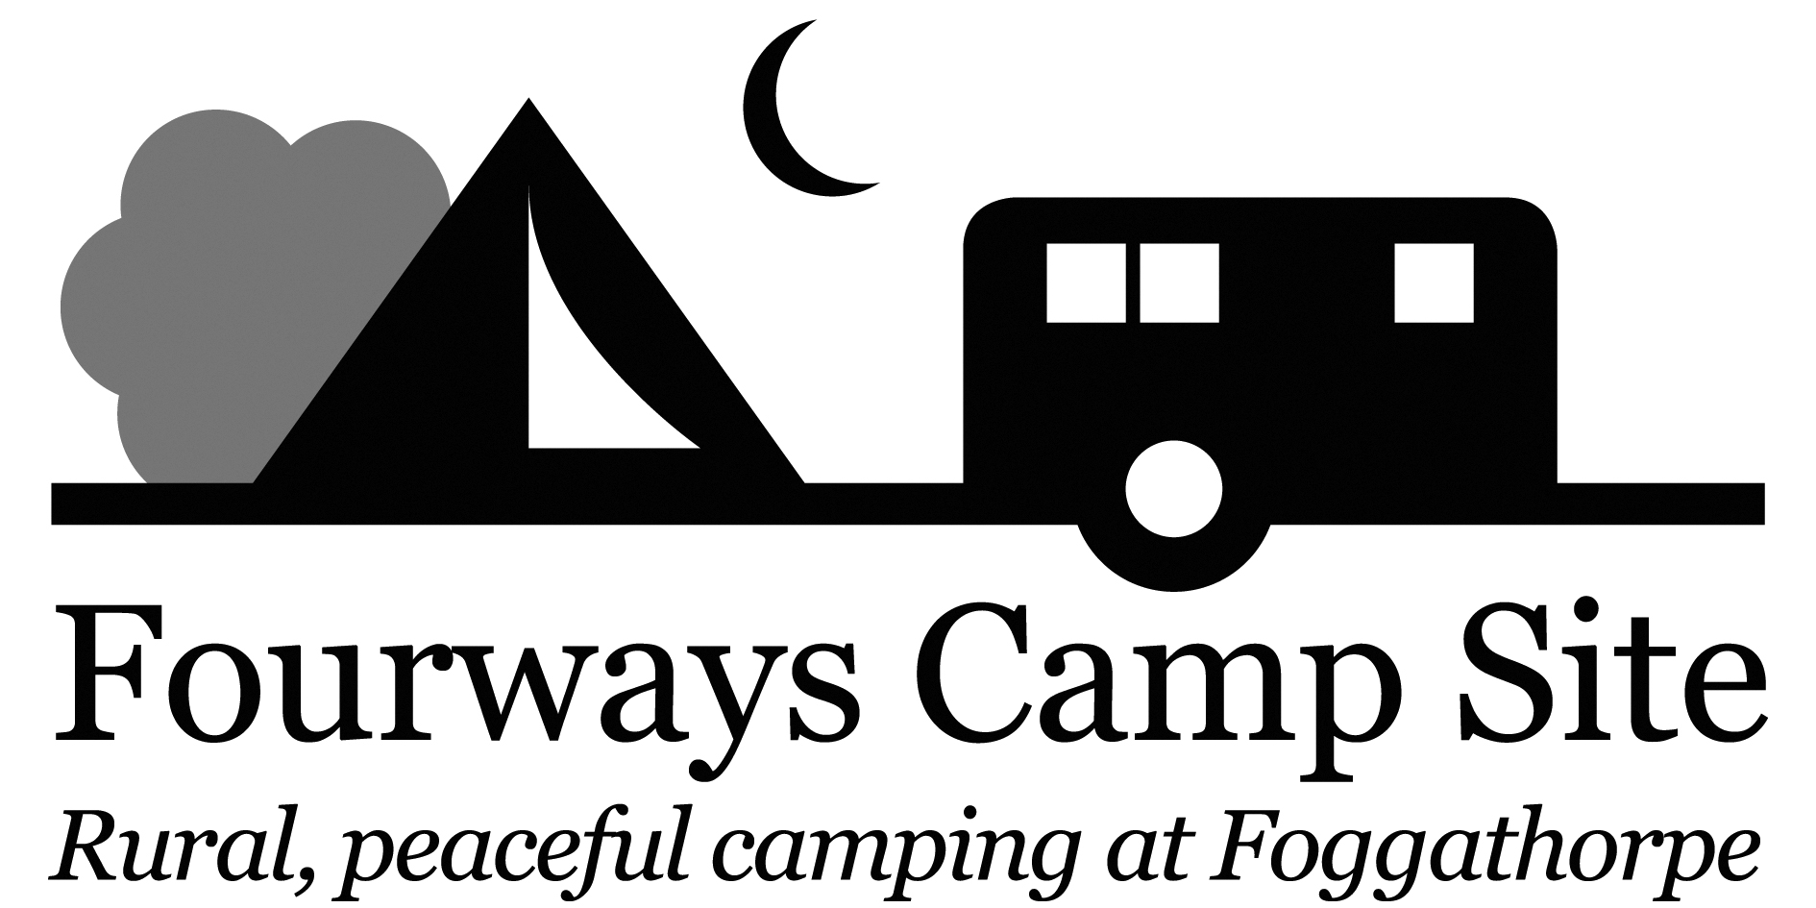

Glamping Pod prices

Mid-Week Rate £35.00 / Night

Weekend Rate £40.00 /Night

Maximum occupancy per unit is 2 adults and 2 children

Arrival after 12 noon
Departure before 11am
Email: fourwayscampsite@ymail.com
WWW.fourwayscampsite.com
TEL: 07432 491526/ 07768 755585 / 01757 289930
Sue & Martin, Fourways Camp Site, Foggathorpe, Nr York, YO8 6PR
…………………………………………………………………………………………………………………………………… BOOKING IN FORM TO BE COMPLETED ON DAY OF ARRIVAL AND RETURNED WITH FULL PAYMENT
NAME ………………………………………………………………………………………………………………………………………………
ADDRESS………………………………………………………………………………………………………………………………………….
…………………………………………………………………………………………………………………………………………………………
…………………………………………………………………………………………………………………………………………………………
TEL NO …………………………………………………………………………………………………………………………………………….
EMAIL ………………………………………………………………………………………………………………………………………………
CAR REGISTRATION …………………………………………………………………………………………………………………………
MEMBER NO …………………………………………………………………………………………………………………………………..
ARRIVAL DATE………………………………………………………………………………………………………………………………….
DEPARTURE DATE…………………………………………………………………………………………………………………………….
NUMBER OF NIGHTS………………………………………………………………............................................................
NUMBER OF ADULTS………………………………………………………………………………………………………………………..
NUMBER OF CHILDREN………………………………………………………………….....................................................
NUMBER OF DOGS…………………………………………………………………………………………………………………………….
DEPOSIT PAID …………………………………………………………………………………………………………………………………...

